Programming II March 26​​, 2018
420­206­AB Worth 3%

Assignment #3 – Part 2
Due: Wednesday, April 4th, 2018 at 23:59
Deductions for late submissions is 10%/day, up to a maximum of 3 days.

1. Consider the following C# structure:

public struct TimeStamp
{
public int hours;
public int minutes;
public int seconds;
}
A TimeStamp​ is a data structure used to hold a time of the day. This assignment​ involves creating a series of methods that work with TimeStamp​ structures.​

Code each of the following methods:

- static TimeStamp ConvertSecondsToTS(int SecondsToConvert)
Take the ​secondsToConvert​, and convert to a proper ​TimeStamp​. Example, if the seconds, parameter is 3700, the ​TimeStamp​ ​should be (seconds=40, minutes=1, hours=1)

- static int ConvertTSToSeconds(TimeStamp TheTimeStamp)
Take the TimeStamp​​, and convert to a total number of seconds, and return. Example, if the TimeStamp​, parameter is (seconds=25, minutes=2, hours=1) the total number of seconds should be 3745.

- static void PrintATS(TimeStamp TheTimeStamp)
Print the ​TimeStamp​ ​in the following format HH:MM:SS, each field should always be 2 digits. Example, 05:22:02. Do not print a newline at the end!

- static TimeStamp AddSecondsToTS(TimeStamp TheTimeStamp, int TheSeconds)
Add TheSeconds​ to the given ​TimeStamp​. Make sure the ​TimeStamp​ ​you return is proper.

- static TimeStamp ReadATSFormUser()
Ask the user to enter the 3 parts of the ​TimeStamp​. Validate that each is in the correct range. Then return the corresponding ​TimeStamp​.
- static TimeStamp AddTwoTS(TimeStamp TimeStampOne, TimeStamp TimeStampTwo)
Return a proper ​TimeStamp​, which is the sum of TimeStampOne, and TimeStampTwo.

Test your methods by writing a Main which calls all your methods. This will allow you to verify you are obtaining the desired results. You do not need to hand in your Main, instead include the main below. Test using the Main method included with this lab, make sure the results you obtain with your methods match those given.
In all the above methods, you must make sure all TimeStamp​ structures, are​ proper. What is a proper TimeStamp​ structure? Seconds must be in the range 0..59,​ minutes must be in the range 0..59 and hours must be in the range 0..23.
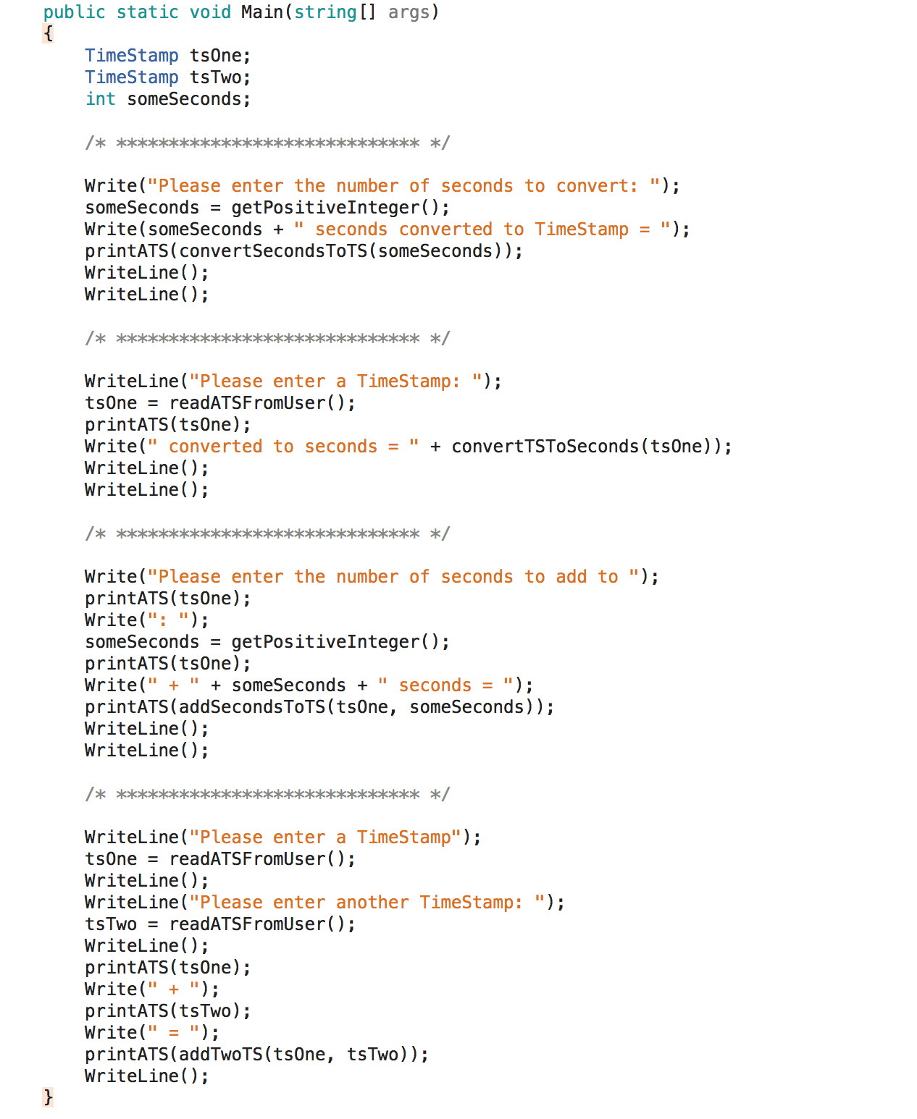
Sample main method for testing:
Sample execution of the above Main method:

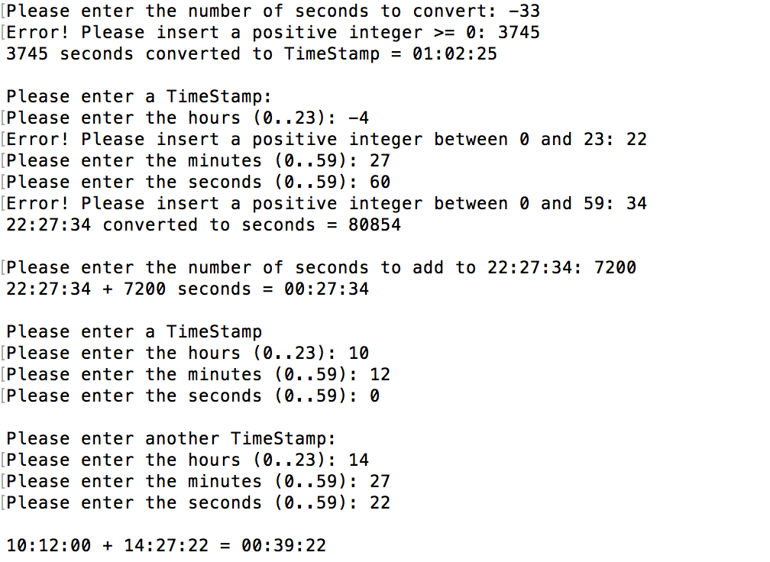

- TimeStamp as a class.

In this question, you will re­write the code from question 1, but, we will change TimeStamp from a structure to a class. Create a separate Visual Studio project for this question.

You will need to implement all of the methods from question 1, as well as creating the following:

    - A default constructor which initializes the TimeStamp to 00:00:00.
    - A constructor that has 3 parameters, _hours, _minutes and _seconds. This constructor will initialize the TimeStamp private members to the values of the parameters. If any parameter is out of range, throw an error is input is invalid.
    - Each private member should have a Property that allows the public to get the value of the member, and set it to a valid value​​. Throw an error is input is invalid.

You will also need to re­write the Main method to work with the TimeStamp class. The updated Main method should produce the exact same results as the sample execution of the Main method from question 1.
Note, when changing the methods from the structure version to the class version, they will look a little different, as discussed.

Here are the methods modified to work in the TimeStamp class:

  - public void ConvertFromSeconds(int SecondsToConvert)
Set these hours, minutes and seconds of the current ​TimeStamp​ instance based on secondsToConvert.

  - public int ConvertToSeconds()
Return total number of seconds in the current ​TimeStamp​ instance.

  - public override string ToString()
Returns as a string: the current ​TimeStamp​ instance in the format HH:MM:SS
Usage: Console.WriteLine(​"​The TimeStamp = ​"​, aTS.ToString());

  - public void AddSeconds(int TheSeconds)
Add TheSeconds to current ​TimeStamp​ instance.

  - public void ReadFromUser()
Ask the user to enter the 3 parts of the ​TimeStamp​. Validate that each is in the correct range. Set the current ​TimeStamp​ instance to the value read in.

  - public TimeStamp addTwoTS(TimeStamp TimeStampOne, TimeStamp TimeStampTwo)
Return a ​new TimeStamp​, which is the sum of TimeStampOne and​ TimeStampTwo ​. Note: the current ​TimeStamp​ instance does not change.

- Operator overloading. (add this code to part 2)

Currently the TimeStamp class is not very elegant. For example, to add 2 TimeStamp objects together you need do the following:

tsThree = addTwoTS(tsOne, tsTwo);

It would be more elegant if we could do the following instead:

tsThree = tsOne + tsTwo;

As we discussed in class, this can be achieved using operator overloading.

- For this question you will need to implement the following two + operations:

public static TimeStamp operator +(TimeStamp timeStampOne, TimeStamp timeStampTwo) {…}
public static TimeStamp operator +(TimeStamp ts1, int seconds) {…}
where int is the number of seconds to add)

- Implement the following 6 comparison operators:

TimeStamp == TimeStamp
TimeStamp != TimeStamp
TimeStamp > TimeStamp
TimeStamp < TimeStamp
TimeStamp >= TimeStamp
TimeStamp <= TimeStamp

- You will also need to re­write the Main method to work with the overloaded operators.

Requirements and Deliverables
Your applications must meet the following requirements:
    - The working code + demo (100% of the grade)
Console.ReadLine();
    - All programs should have ​​ ​​
    - Not demoing your working code on the teacher designated time and in class is automatically a deduction of 15%.
- Clean your Visual Studio Project (Build­>Clean solution). Compress all solution folders and their softcopy flowcharts.
- Compress all the project folders into into a ZIP file (retain the tree structure please!) and submit this on LEA

